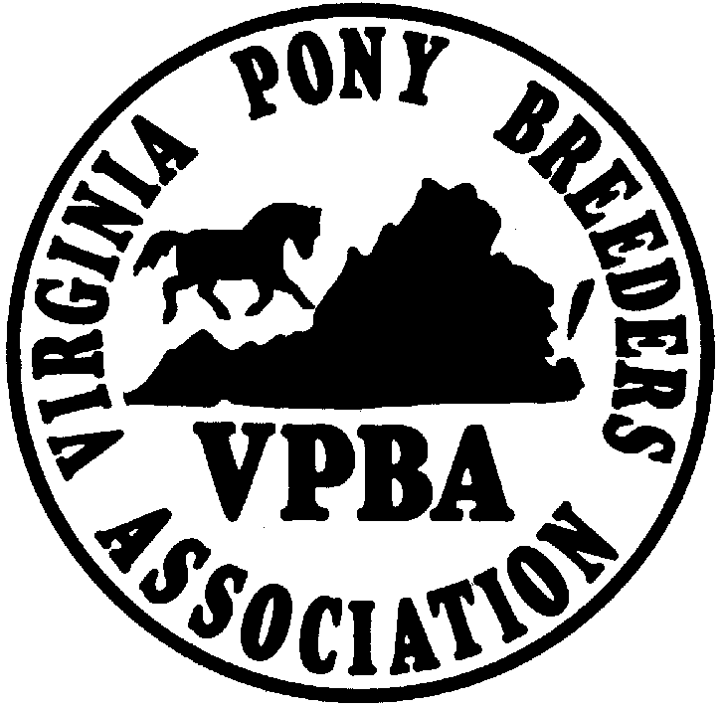 VIRGINIA PONY BREEDERS ASSOCIATION
FUTURITY PROGRAM
1612 Shallowell Road
Manakin Sabot, VA 23103
804/784-5441; grpresson399@gmail.com

2027 YEARLING FUTURITY NOMINATION FORM

Nomination deadline is March 31, 2026

This form must be completed fully and returned to the above address with payment:
($100 total or $15 Nomination Fee per entry).

Please print the following information.

BREEDER (Owner of dam at time of foaling. Designate a single individual.)

________________________________________________________________________________________

ADDRESS_______________________________________________________________________________

CITY__________________________________________STATE___________ZIP_____________________

PHONE___________/__________________________e-mail_______________________________________

Breeder (owner of dam at time of foaling) must be a 2026 VPBA member who participates (owns breeding stock) in the Virginia Horse Breeding industry.

Please check your status below:
_______I participate in the Virginia Horse Breeding industry, and my $35 VPBA dues are enclosed.
_______I participate in the Virginia Horse Breeding industry, my 2026 dues have been paid previously.

*SIGNATURE*____________________________________________________________________

Each dam must be VPBA registered/recorded as owned or leased by the breeder making the nomination.
ENCLOSE A COPY of each dam’s registration/recording certificate or an application for such.

1. Sire of expected foal_____________________________________________________________________

Dam of expected foal ____________________________________________________________________

Dam’s VPBA #_____________________Dam’s Sire___________________________________________

2. Sire of expected foal_____________________________________________________________________

Dam of expected foal_____________________________________________________________________

Dam’s VPBA #_____________________Dam’s Sire___________________________________________

3. Sire of expected foal_____________________________________________________________________

Dam of expected foal_____________________________________________________________________

Dam’s VPBA #_____________________Dam’s Sire___________________________________________

